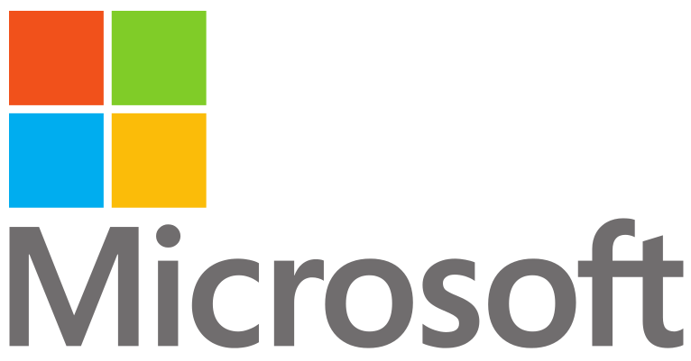

**Company Profile**

Microsoft Inc.’s origins date back to 1975 when Bill Gates and Paul Allen developed BASIC, a programming language for Altair 8800 (one of the firsts micro-computers, by MITS). It actually worked and they sold the license to MITS. Allen and Gates gave up respectively working with MITS and studies at Harvard, they had found the Microsoft. They developed new BASIC’s versions that could talk with other calculating machines, to collaborate with other companies.

In the ‘80s, Microsoft put in commerce its first hardware product (Z80 Card), an immediate success. The card enabled the Apple II computer to run the industry-standard business software and operating system of the time. They saw 5000 sales of the product in its first three months on the market. The cards sold at $349 each, which produced an impressive profit their first year in production.

Their first operating system also came in 1980 (Xenix), and was a variation of Unix that they had acquired distribution rights to from AT&T.

DOS was the first operating system that really propelled the company forward to success. IBM gave a contract to Microsoft to produce an operating system for their new IBM Personal Computer. Microsoft did not have an operating of its own to meet the needs of IBM, and purchased a clone of the CP/M system that was popular at the time, and IBM redubbed it IBM PC DOS. It was offered at a much lower price than CP/M, and became the standard of the time because of that.

Later, in 1983, Microsoft partnered with a handful of other companies to produce its own version of DOS. The company aggressively pushed the system, familiar to people around the world as MS-DOS, on personal computer manufacturing companies and surged to the top of the market.

In 2001 the company released Windows XP, is widely considered Microsoft’s greatest operating system to date. The company has continued to focus heavily on the home user throughout the 2000s and today they dominate the home environment in the form of software, personal computers and gaming devices, and much more.

From humble beginnings to worldwide success, Microsoft’s legacy is a truly remarkable story.